Northwind Traders Dashboard

Submitted by:
Name: S.SHERENE
Roll no: E25FA067
Department: B.Com FinTech and AI
Year of Study: 2nd Year
Introduction
The Northwind dataset represents the business operations of a company engaged in the sale and distribution of food and beverage products. It contains information on customers, products, categories, orders, employees, suppliers, and shipping details. In this project, the dataset is analysed using Microsoft Power BI to examine sales trends, product and category performance, customer distribution, employee performance, and freight costs. Interactive visualizations and filters are used to identify meaningful patterns and support data-driven business analysis.
Objectives
Before Starting, I set out with a few clear goals for what I wanted the dashboard to do:
- To analyse the sales performance of the Northwind dataset.
- To identify trends in sales and order volumes over time.
- To evaluate product and category performance.
- To analyse customer and geographical distribution.
- To examine employee performance and order handling.
- To analyse freight costs and their impact on business operations.
- To present the findings through interactive dashboards and visualizations for effective decision-making.
Dataset Description
The Northwind dataset is a relational business dataset that contains information related to the sales and distribution of food and beverage products. It includes data on customers, products, product categories, employees, orders, and shipping activities. In this project, the dataset is analysed using Microsoft Power BI to identify sales trends, product performance, customer distribution, order patterns, and freight costs.
Fields Used
The main fields used in the Power BI dashboard are:
- Product Name – identifies the products sold.
- Category Name – represents the product category.
- Employee Name – identifies employees associated with orders.
- Country – represents the geographical location of customers.
- Region – represents the customer region.
- Order Date – used to analyse sales and orders by year and month.

Measures Used
The following measures are used for analysis and visualization:
- Total Sales – calculates the overall sales generated.
- Total Quantity Sold – represents the total quantity of products sold.
- Total Orders – calculates the total number of orders.
- Total Freight – represents the total shipping/freight cost.
- Average Freight – calculates the average freight cost per order.
- Number of Customers – represents the number of customers in the dataset.
These fields and measures are used to create interactive visualizations that provide insights into sales performance, product and category trends, customer distribution, employee performance, order volume, and shipping costs.
Data Preparation
The Northwind dataset is prepared by cleaning and validating the data, handling missing or duplicate records, and ensuring that fields have appropriate data types. Unnecessary fields are removed, while relevant data is transformed for analysis. Relationships between tables such as Customers, Orders, Products, Categories, and Employees are established, and necessary measures such as Total Sales, Total Orders, Total Quantity, and Total Freight are created using DAX.
DAX Measures Used
The dashboard uses several measures to make the top-level information easier to read:
- Total Sales – calculates the total sales generated from the order details.
- Total Orders – calculates the total number of orders.
- Total Quantity Sold – calculates the total quantity of products sold.
- Total Freight – calculates the total freight/shipping cost.
- Average Freight – calculates the average freight cost per order.
- Number of Customers – calculates the total number of customers.
These measures allow the dashboard visuals to work with summarized sales and financial information instead of displaying only individual records.
Dashboard Components
The finished dashboard is made up of the following visuals.
- Cards
Cards are useful when we want to display important data in a concise manner. The reader of the report can also give a quick glance at the important data in a quicker manner.
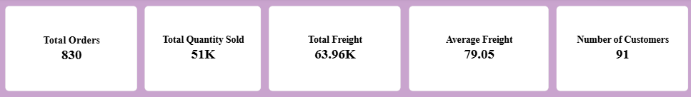
- Total Orders by Month
Line Charts are useful when we want to show the trend over the time. In the below pic it could be easily noted in which month there were high orders and low orders.
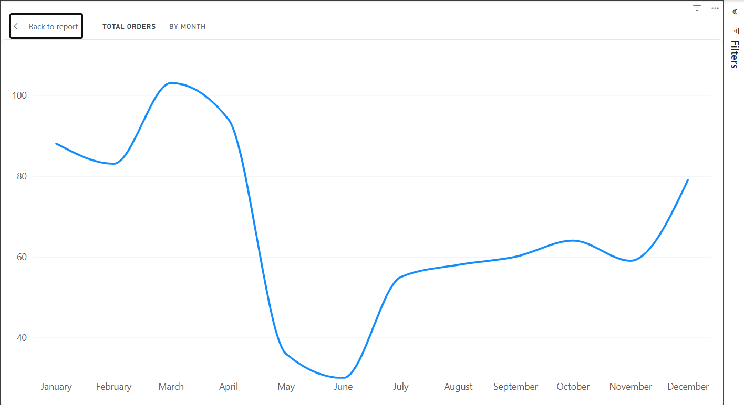
- Total Sales by Category
The Clustered Column chart below shows the total sales by the category name allowing for easier analysis of the chart.
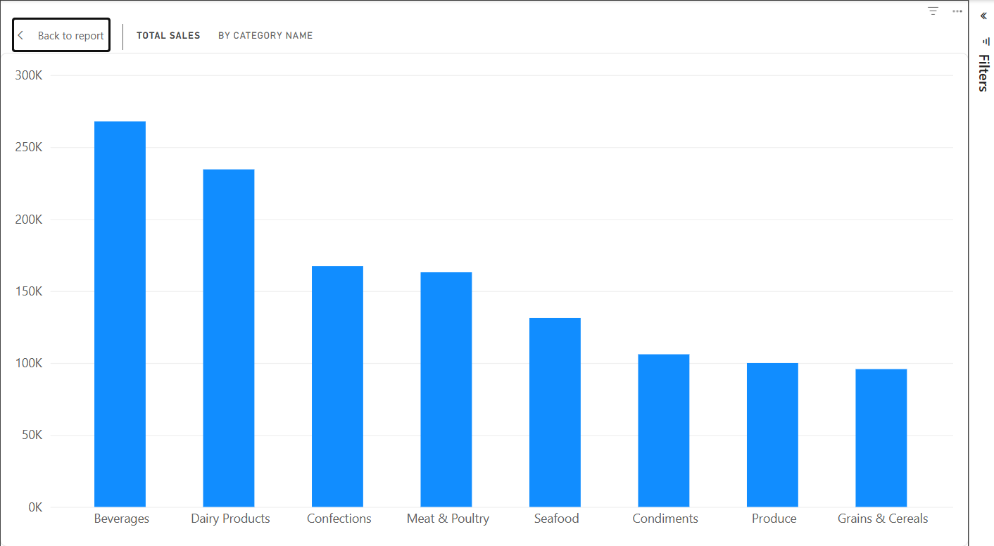

- Total Orders by EmployeeName
The Clustered Bar Chart shows the total orders by employee name. This lets us analyse easily which employee made huge orders and which employees made the least orders.
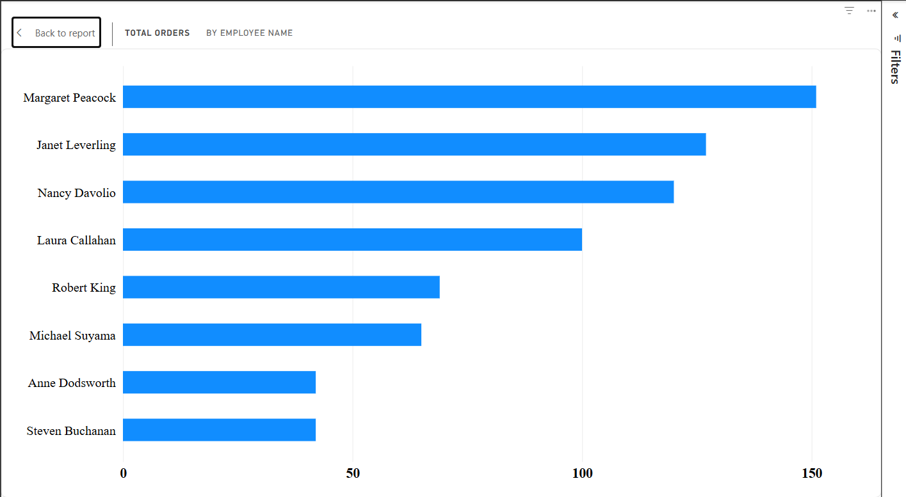
- Product Sales Summary
The following Product Summary Table, shows us the datas as well as allow us to do easy data validation.
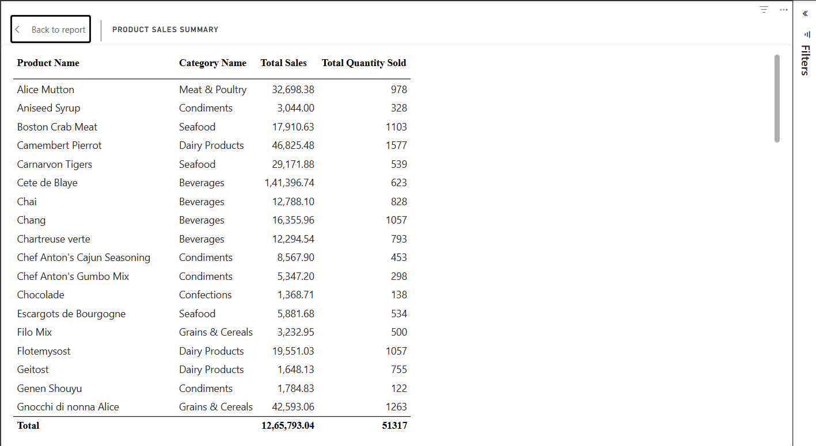

- Customers by Country
This Clustered Bar Chart shows us the customers by country. This shows where there is high marketing and least marketing.
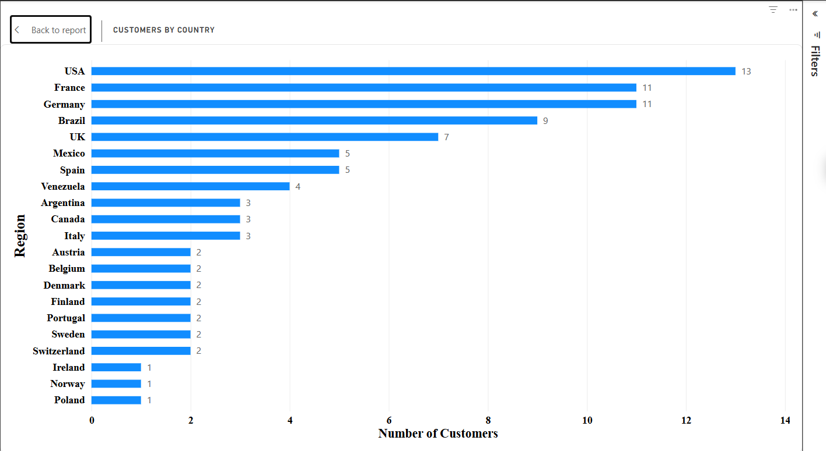
- Slicers
Slicers are useful when we are creating a interactive dashboard and when we want to show the data for a specified time period or any categories.
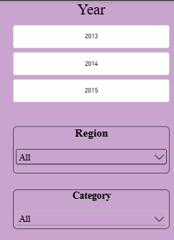

- Category Tooltip
Tooltips are useful when we want to obtain a data and we don’t want to move from that page. We use our cursor above the chart/graph and it shows the specific details in that time.
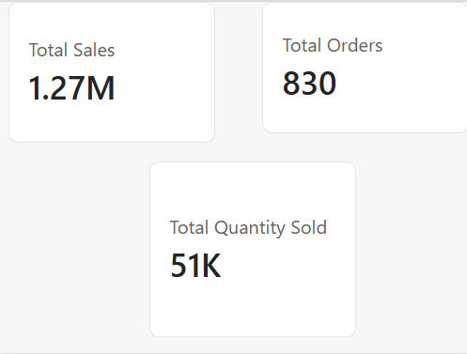
Key Findings
A few things stood out once the dashboard was complete:
- Sales performance varies across different product categories and products.
- Order volume fluctuates over time, showing changes in customer demand.
- Certain products contribute significantly to total sales and quantity sold.
- Employee performance differs based on the number of orders handled.
- Customer distribution varies by country and region, indicating differences in market presence.
- Freight costs vary across orders, providing insight into shipping expenses.
- The dashboard helps identify important patterns in sales, products, customers, orders, employees, and freight costs.
Conclusion
This project provided practical experience in applying Microsoft Power BI for systematic business data analysis and visualization. It enhanced my understanding of data preparation, data modelling, DAX measures, and interactive dashboard development. The analysis of the Northwind dataset provided insights into sales performance, product and category trends, customer distribution, employee performance, and freight costs. Overall, the study demonstrates the significance of business intelligence and data visualization in converting complex datasets into reliable, interpretable, and actionable information, thereby supporting evidence-based analysis and informed managerial decision-making.
References
- Microsoft Power BI Desktop
- Dataset 3 — Northwind Traders Dataset
- Microsoft Power BI Documentation

